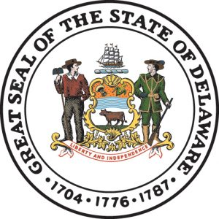

Report to the Governor on Fire and Building Code Modernization
June 22, 2026
Submitted by
John W. Rudd
State Fire Marshal
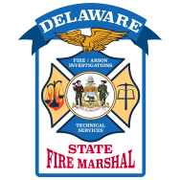

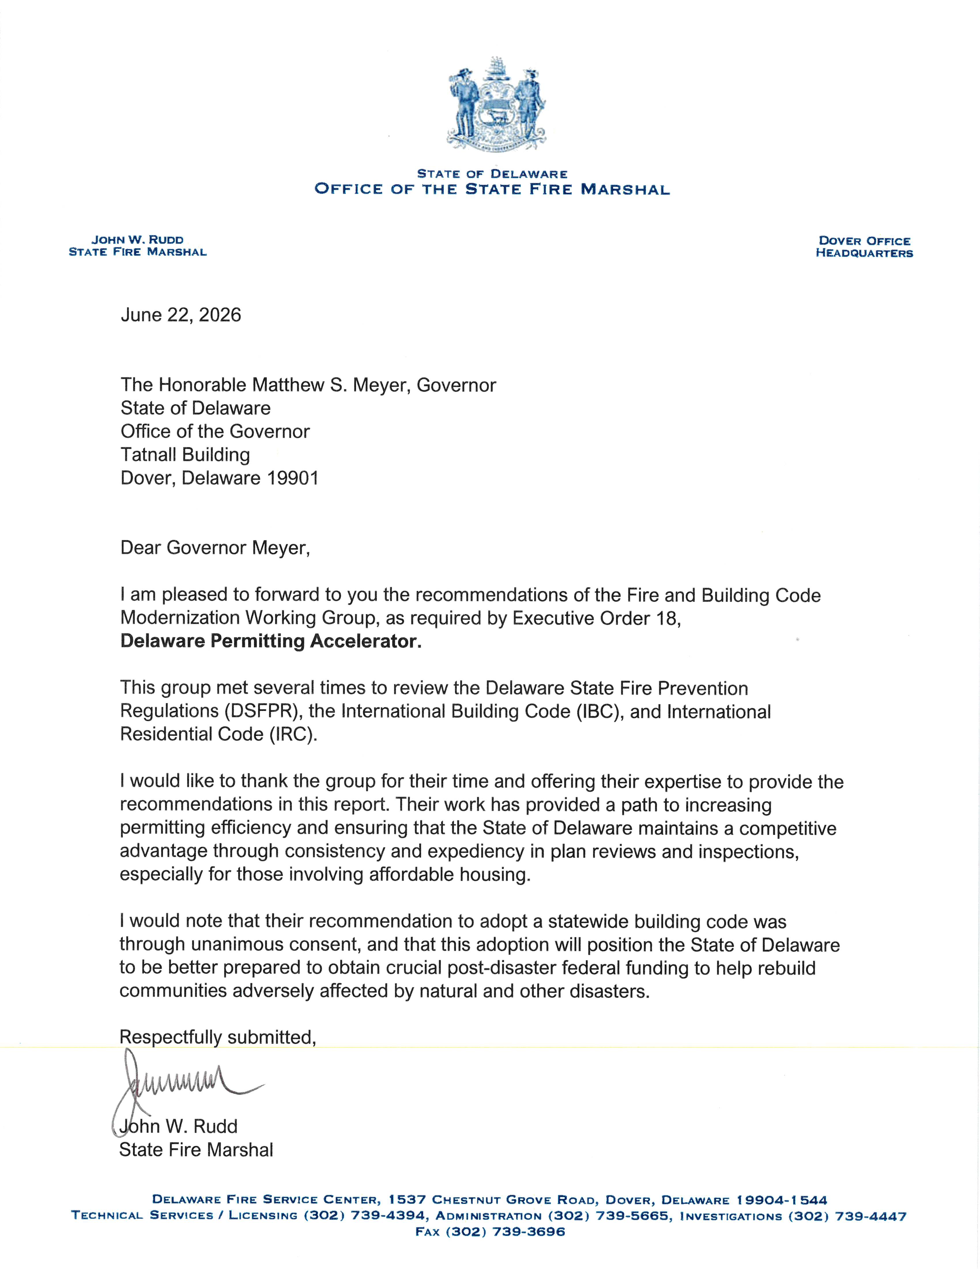

Executive Summary
Pursuant to Section 4(f) of Executive Order 18 (EO18),
State Fire Marshal John W. Rudd convened a diverse working group of state and local officials, fire service leaders, building code officials, architects, engineers, and residential/commercial builders to review the Delaware State Fire Prevention Regulations and building code practices. The group was tasked with identifying opportunities to reduce barriers to affordable housing, multi-family developments, and infill projects while maintaining or enhancing public safety.

Key Findings
- Delaware maintains a statewide fire code that is largely uniformly enforced, with only minor procedural differences across jurisdictions.

- In contrast, Delaware does not have a statewide building code. Building code enforcement varies significantly by county and municipality, with differing code editions, plan review processes, and inspection practices.

- These inconsistencies increase project costs, extend timelines, and create unpredictability — particularly burdensome for affordable and multi-family housing projects.

- No specific code provisions were identified as outright barriers to affordable housing; however, process fragmentation and differing standards drive delays and added expenses.

Alignment with Executive Order 18
These recommendations directly support EO18’s goals of accelerating permitting, reducing barriers to affordable housing, and improving coordination across state and local agencies. Implementation is expected to reduce design and permitting timelines, lower soft costs, and increase housing production without compromising safety.

Anticipated Impact
Proper implementation of these proposals, combined with other elements of the Delaware Permitting Accelerator, will create a more efficient, predictable, and cost-effective regulatory environment for all construction types, with specific benefits for affordable, multi-family, and infill housing projects across Delaware.

Conclusion
The working group emphasizes that affordability must never come at the expense of safety. With balanced stakeholder-informed reforms, Delaware can modernize its regulatory framework to meet urgent housing needs while upholding high standards for life safety and construction quality.
Working Group Membership
Office of the State Fire Marshal
State Fire Marshal John W. Rudd (Chair)
Chief of Technical Services Duane T. Fox, Jr.

Office of the Governor
John Kane
Collin Willard

City of Dover Fire Marshal
Fire Marshal Jason Osika

Delaware State Fire Chiefs Association
President Jeff Brown

Fire Protection Consultant/Private Industry
Roger Boyce

Wilmington Fire Department
Fire Chief John Looney

New Castle County Building Code Official
Joseph Day, III

Kent County Building Code Official
Scott Tanner, CFM
Amy Minner

Sussex County Building Code Official
Andy Wright

DNREC Energy Office
Brian Geller

9th Street Development Company – Commercial and Residential Construction
Stephen Weathers

Schell Brothers – Residential Construction
Mark Moore

Becker Morgan Group – Commercial Architecture
Bryan Hutchison

Davis Bowen and Friedel – Civil Engineer
Zac Crouch

Atwell – Civil Engineer
Dev Sitaram

Architectural Alliance – Affordable Housing Architecture
Kevin Wilson

Blenheim Homes – Residential Construction
BJ Carey

RY Johnson – Commercial construction
Dean Johnson

Leon Wiener and Associates
Debra Finocchiaro

Ryan Homes
Scott Evans

Carl M. Freeman Companies
Smith Purdum

Background
Governor Matthew Meyer signed Executive Order Number 18 (EO18), which developed the Delaware Permitting Accelerator. EO18 is intended to address affordable housing issues in the State of Delaware.

Section 4 (f) of EO18 directed the State Fire Marshal to convene a working group to review and suggest any changes to the Delaware State Fire Prevention Regulations, including proposals for statewide fire and building codes, ways to expedite infill site development in urban settings, and ways to differentiate urban and rural development site concerns. The working group was required to prepare a report with proposals within 120 business days of the Order.

As a result of the order, State Fire Marshal John Rudd convened a working group consisting of State governmental representatives, representatives from the Office of the State Fire Marshal, DSHA, the Delaware Fire Service, building code authorities from each County, construction industry representatives which included architects, engineers, construction and safety experts.
Committee Process
The State Fire Marshal split the committee into two subcommittees, a fire code subcommittee and a building code subcommittee. The subcommittees were charged with reviewing the respective codes, enforcement practices, and policies within each subcommittee.
Any member of the committee could participate in either or both subcommittee meetings. In general, subcommittees broke down as follows:
Fire Affiliates
Roger Boyce Jason Osika
John Looney Jeff Brown

Building Code Affiliates
Scott Tanner Andy Wright
Amy Minner Joseph Day, III (Building Code chair)

State Government Affiliates
Brian Geller Collin Willard
John Kane Duane T. Fox, Jr. (Fire Code chair)
John Rudd

Architectural & Engineering Affiliates
Kevin Wilson Dev Sitaram
Bryan Hutchison Zac Crouch

Commercial and Residential Builder Affiliates
BJ Carey Dean Johnson
Debra Finocchiaro Mark Moore
Scott Evans Stephen Weathers
Smith Purdum
All meetings were conducted by virtual means on an opposing bi-weekly basis. Each meeting started with an agenda and minutes were developed and distributed.
Current Challenges and Findings
In the first working group meeting it was identified that while the State had a statewide fire code, the State does not have a statewide building code. As a result, during the subcommittee reviews several items were identified as follows:
- In addition to the State Fire Marshal enforcing the Delaware State Fire Prevention Regulations statewide, the City of Wilmington, City of Dover, City of Newark, and the City of New Castle each have their own fire code enforcement effort. Each of these jurisdictions must enforce the minimum State Fire Prevention Regulations and are ultimately under the jurisdiction of the State Fire Marshal and State Fire Prevention Commission. As a result, the State Fire Prevention Regulations are uniformly enforced statewide without major differences. It was determined that some of the plan review processes are different among enforcement agencies.
- Multiple political subdivisions (cities and counties) enforce some form of a building code.
- Building code enforcement varies greatly due to jurisdictions enforcing different editions of the building code.
- Some jurisdictions use building code third-party plan review and/or inspection services. In some cases, this process increased time and frustration during the permitting process.
- Although neither subcommittee found specific barriers to affordable/multi-family/infill housing, the building code subcommittee did find that having different building code/editions and permitting process created an increase in construction cost due to process and time delays.
Recommendations
The Fire Code Subcommittee and Building Code Subcommittee have developed separate recommendations as follows:
Fire Code Subcommittee Recommendations
Committee Comment - Remember that recommendations for affordability should never come at the expense of safety. Haphazard implementation could have detrimental consequences.
- Recommend a single exit stair option for up to 4-stories in apartment (residential occupancies) only. The State Fire Prevention Commission should develop any necessary requirements to ensure adequate life safety for the occupants and first responders.
- Investigate funding and minimum requirements for affordable housing. Ensure the same parameters are followed for non-DHSA funded projects as well.
- Recommend pre-development meetings with State, County, Municipal, and/or third-party review representatives. These would be similar to PLUS but closer to when the project will be designed for review and permitting.
- Recommend in the residential units only that stair dimensions be consistent between ICC and NFPA codes. ICC will allow risers to be not greater than 7 ¾” with not less than a 10” tread. This would require a change to the State Fire Prevention Regulations.

- Recommend State Fire Prevention Regulations (NFPA 101 Life Safety Code) be consistent with IBC regarding accessible residential units. IBC has different requirements for structures with an elevator and without an elevator. Accessible units require the installation whereas non-accessible units are only required to have blocking installed for the future need of a grab bar. NFPA currently requires all units to have grab bars installed prior to completion of the project.

Building Code Subcommittee Recommendations
1. Adopt a Statewide Building Code - The State of Delaware should adopt and maintain a statewide building code to provide consistency, predictability, and uniform minimum standards for the design, construction, alteration, and maintenance of buildings throughout the state.
2. Establish a Statewide Building Code Commission - A statewide commission should be created to administer and oversee the statewide building code. The commission should be structured similarly to the existing Fire Prevention Commission and be responsible for code adoption, interpretation, appeals, training, and technical assistance.
3. Ensure Broad Stakeholder Representation - The commission should include representatives from all three counties and a diverse group of stakeholders, including:
  - Building code officials
  - Municipal and county government representatives
  - Residential and commercial builders
  - Architects
  - Engineers
  - Developers
  - Fire service representatives
  - Industry and professional organizations
  - Members of the public

4. Establish a Two-Tier Appeals Process - Local jurisdictions should continue to maintain local boards of appeal for building code decisions. Appeals from local boards should be eligible for further review by the State Building Code Commission to ensure consistent statewide interpretation and application of the code.
5. Permit Local Amendments That Increase Standards - Local jurisdictions should be permitted to adopt amendments to the statewide building code provided such amendments do not reduce or weaken the minimum standards established by the statewide code.
6. Preserve Local Administrative Authority - Local jurisdictions should retain authority to amend and administer administrative provisions necessary for local enforcement, including:
  - Permit administration
  - Inspection procedures
  - Enforcement mechanisms
  - Penalties
  - Appeals procedures
  - Contractor registration requirements
  - Fee schedules

7. Provide Statewide Training and Technical Assistance - The commission should be responsible for developing and delivering training programs, technical assistance, and code interpretation guidance to promote consistent application and enforcement throughout Delaware.

8. Develop a Statewide Building Code Best Practices Guide - The commission should develop and periodically update a Best Practices Guide for local jurisdictions that promotes customer service, efficiency, and consistency. The guide should include recommendations regarding:
  - Standardized permit application procedures
  - Plan review and inspection checklists
  - Published review timelines
  - Publicly available fee schedules
  - Designated points of contact for applicants
  - Electronic permitting systems
  - Performance metrics and reporting
  - Customer service standards

9. Evaluate Statewide Contractor Licensing - The commission should study the feasibility and benefits of statewide licensing for general building contractors, similar to existing statewide licensing programs for plumbing, mechanical, and fuel gas contractors. Any statewide licensing framework should allow local jurisdictions to retain contractor registration requirements for local administration and enforcement purposes.
10. Maintain Separation from Zoning and Subdivision Regulations - The statewide building code should regulate building construction and safety standards only and should not incorporate or preempt local zoning, land development, subdivision, or land-use regulations. Local governments should retain authority over planning and land-use matters.
Impact Analysis
It is the consensus of the committee that proper implementation of the above recommendations, combined with the Delaware Permitting Accelerator, will significantly improve construction efforts for all construction within the State of Delaware, including affordable/multi-family/infill housing.
The result will be a faster design process and a more efficient permitting process to advance Delaware’s Affordable Housing needs.
References and Bibliography
- Delaware State Fire Prevention Regulations, 2026 edition (DSFPR)
- International Building Code, various editions (IBC)
- International Residential Code, various editions (IRC)
- NFPA 101, Life Safety Code, 2024 edition (101 LSC)
- National Fire Protection Association (NFPA)
- International Code Council (ICC)

